For Immediate Release: Tu Aug 6
Contact: Bridget Lee-Calfas, Public Information Director, 217/333-6282, bklee@illinois.edu

ELLNORA | The Guitar Festival: Timmy D and Blind Justice Ignite Pre-Festival Local Heroes Night
Tuesday, September 3, 2013, at 6:30pm, FREE

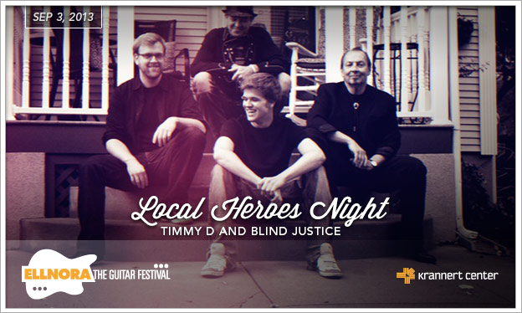

Local axe slammers representing the best of Champaign-Urbana’s music scene will perform in true ELLNORA style in a FREE pre-festival Local Heroes concert on Tuesday, September 3 at 6:30pm. Tim Donaldson of Timmy D and Blind Justice has curated a lineup that promises a high-energy night of rock standards and original music. In addition to the Texas and British blues-influenced Blind Justice, the audience can expect appearances by Brandon Washington, Gloria Roubal & Paul Sabuco, David Howie & Lou DiBello, The Diva & The Dude/Kathy Harden & Andy Baylor, Tim Frazier, Megan Johns, Michael Carpenter of The Decadents, Justin Larkin & Christopher Kunz, Dyke Corson, and Kenna Mae Riess.

Krannert Center Senior Associate Director Rebecca McBride remarked that “Local Heroes Night celebrates the grand rock band tradition that has thrived in Champaign-Urbana since the 1960s. Every CU music lover will appreciate this tribute to our community’s rock ‘n’ roll spirit as we rev up to the start of ELLNORA | The Guitar Festival 2013.“ In the same sense of community pride, The Art Theater Co-op will present Robert Zimmerman’s CU music scene documentary, Out of Nowhere, on Wednesday, September 4, at 7:30pm.
Watch the film trailer at http://www.youtube.com/watch?v=VqmOQcq0WcI&feature=youtu.be.

And for regional residents who are ready to warm up for ELLNORA even sooner—check out Tim Donaldson’s special guest appearance with the Tons O’ Fun Band on Saturday, August 24, at the Urbana Sweet Corn Festival.

Visit KrannertCenter.com or EllnoraGuitarFestival.com to learn more about Local Heroes Night and the entire lineup for ELLNORA | The Guitar Festival at Krannert Center, September 5-7, 2013.

