Speak Up

For Peace & Justice

Against the U.S. Endless Wars & the Muslim and Refugee Bans

Please follow your participation in the Seventh Art Stand with sustained challenge to the U.S. foreign policy and increasing military spending via the social media, letters to the editor, opinion pieces, petitions, contacting your members of congress, and engaging those around you.
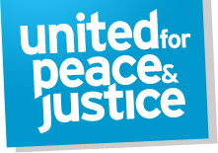
No religious discrimination, No Muslim Ban!
Refugee are welcome here. Remember, most of them are victims of the U.S. military aggressions.

http://petitions.moveon.org/sign/do-not-stop-refugee-resettle

http://petitions.moveon.org/sign/reject-trumps-muslim
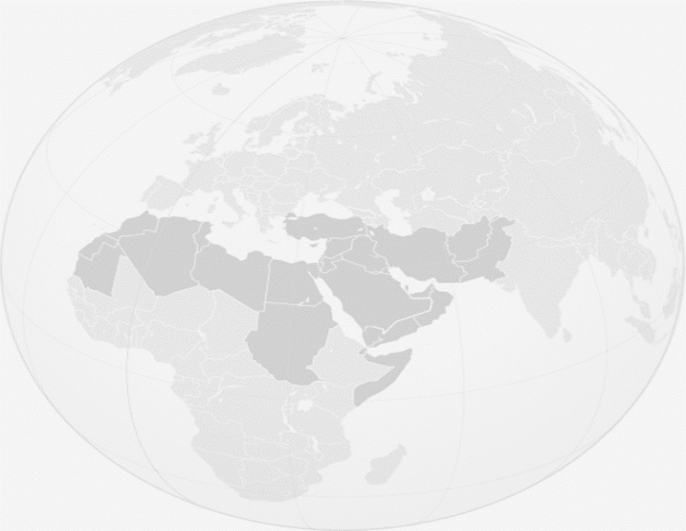

- By the strictest criteria, the U.S. is now fighting in nine countries; its Special-Operations forces are active in over 130 countries.

- The $ 600 billion military budget is over 60% of the discretionary budget at the expense of vital domestic needs.

- The new Administration requests $ 54 billion increase to Pentagon budget! http://peacepledge.unitedforpeace.org/trumps-military-budget/

- Most of the foreign military (security) aid & arms sales go to states with severe human rights violations; some of it falls into the hands of the “wrong” people, like ISIS & corrupt officials.

- Arms sales to Saudi Arabia have enabled it to fight in Bahrein & Yemen. The humanitarian situation in Yemen is dire and famine has been spreading in the country. http://petitions.moveon.org/sign/stop-the-violence-in-1

- War cries against Iran has become loud again &despite of its full compliance with the terms of Iran Nuclear Deal, most of the imposed sanctions remain intact.
https://www.petition2congress.com/ctas/stop-war-machine-petition-peace

