Women Helping Women:
Addressing Gender-Based Violence and HIV in Burundi

Urbana-Champaign Friends Meeting
1904 E. Main, Urbana, IL
Wednesday, October 11, 2017 at 7 PM

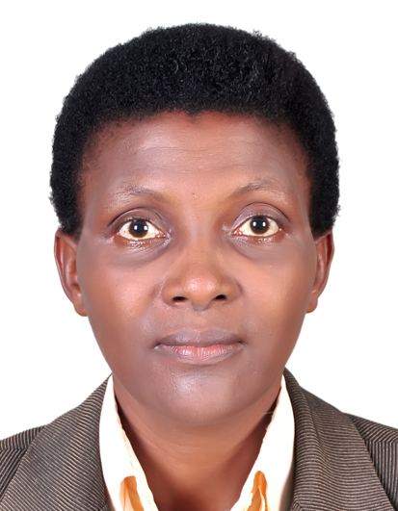

Parfaite Ntahuba
Quaker Pastor in Burundi
Director of Friends Women’s Association

Pastor Parfaite Ntahuba will talk about projects that provide health services to women and their families affected by HIV/AIDS, as well as economic and social reintegration of women who have survived gender-based violence.

Donations to FWA will be welcomed. Please make checks out to Friends Peace Teams with FWA on the memo line.

The public is welcome. For more information, please contact Charlotte Green, charlotteg588@gmail.com

