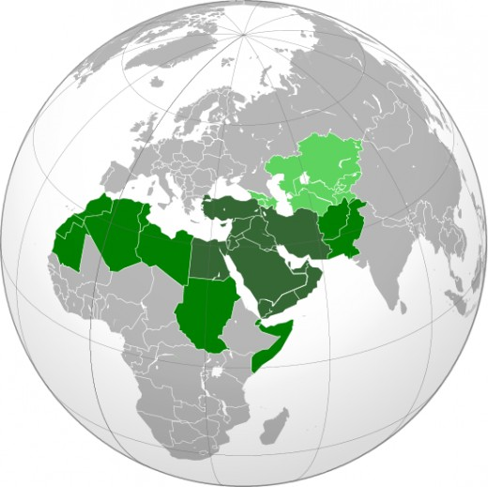
Senator Dick Durbin
on
American Foreign Policy and
the Middle East and North Africa

Saturday March 10, 2012, 1:00-2:15 PM

McKinley Foundation
Second floor, Westminster Hall
809 South Fifth Street, Champaign

Urbana-Champaign Peace Initiative (UCPI) invites you to a talk by Senator Dick Durbin on current developments and conflicts in the Middle East and North Africa and their implications for American Foreign Policy. After the talk, the Senator will respond to questions from the audience.
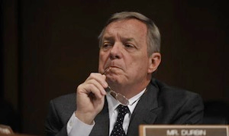
Senator Durbin is the senior United States Senator from Illinois and the Senate Majority Whip, the second highest position in the Democratic Party leadership in the Senate. He is a member of the Senate’s Foreign Relations Committee.
For further information, please write to UCPI ucpinitiative@gmail.com or contact John Setterlund at (217) 828-1038.

