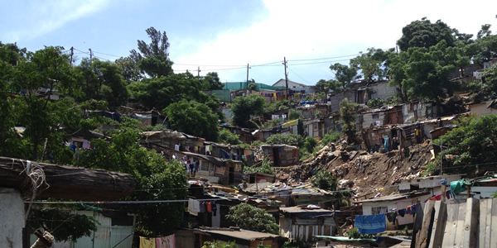

Richard Pithouse

Thought Amidst Waste:
Politics in Shack Settlements in
South Africa

March 7, 4 PM
Knight Auditorium, Spurlock Museum

Richard Pithouse, a South African scholar, journalist and activist with the Durban shack dwellers’ movement Abahlali baseMjondolo, will lecture on the political history of shack settlements in South Africa and contemporary shack dwellers’ struggles as they illuminate the prospects for emancipatory politics among the poor. Sponsored by Illinois Program for Research in the Humanities and the History Department, the lecture is free and open to the public.

Mr. Pithouse’s talk is also part of a week of activities as visiting scholar, listed on the back. Those attending the talk may wish especially to view the film DEAR MANDELA at the University YMCA Mar. 4 or Mar. 8 at 7:30 pm.

Richard Pithouse, Visiting Scholar Schedule, March 4-9 2013

Richard Pithouse lectures in Politics at Rhodes University in Grahamstown, South Africa. He is a scholar, journalist, and activist with the Durban, South Africa shack dwellers’ movement Abahalali baseMjondolo. His visit is part of the History Department’s World Histories from Below initiative and is also sponsored by the Illinois Program for Research in the Humanities, the George A. Miller Visiting Professors and Scholars Program, the Departments of Sociology, Geography, Urban and Regional Planning, the Center for African Studies, the Center for Global Studies, and the University YMCA.

Mon. Mar. 4 “Urban and Housing Activism From Below,” 3 PM
313 Gregory Hall: Panel Discussion including
Richard Pitouse, visiting Scholar, Rhodes University, South Africa
Asef Bayat, Sociology
Ken Salo, Urban and Regional Planning
Tariq Ali, History

Mon. Mar. 4 “Dear Mandela” film screening, 7:30 PM
University YMCA, 1001 S. Wright St., Urbana

Thurs. Mar. 7 IPRH “Revolution Theme” Lecture: “Thought Amidst Waste: Politics in Shack Settlements in South Africa,” 4 PM, Knight Auditorium, Spurlock Museum

Fri., Mar. 8 “Dear Mandela film screening, with discussion, 7:30 PM
University YMCA, 1001 S. Wright St., Urbana

Sat., Mar. 9 Champaign Public Library, Robeson Rooms

10 AM Room B “DEAR MANDELA” discussion and planned Skype discussion with Abahlali Members or Director (please view film Mar. 4 or 8, or online free streaming through Feb. 28 on AfroPop: http://video.pbs.org/video/2328714078/

2 PM Rooms A&B Community Panel on “Community Knowledge” in Durban and South Africa, addressing Environmental Justice, Immigrant Issues, Incarceration, etc.
Refreshments provided

