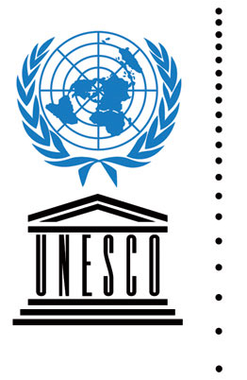

UNESCO CENTER FOR GLOBAL CITIZENSHIP

The public is invited to the inaugural event of the new
UNESCO Center for Global Citizenship
Please join us! Learn about the goals of the new Center, partnership ties with UNESCO associations across the world, upcoming activities including a guided visit to the UNESCO World Heritage Site of Cahokia Mounds in Illinois, museum tours, reading/discussion groups, guest speakers, school events, and traveling exhibitions.

Monday, April 15, 2013
5:00 – 7:00pm
Champaign Public Library
Robeson Rooms A&B

UNESCO and the Mission for Peace in a Troubled World
Mr. Guy Djoken
Executive Director, UNESCO Center for Peace
Washington, D.C.
Introduction by Professor Barbara Ford, Director of the Mortenson Center
for International Library Programs at the University of Illinois Library
Member of the U.S. National Commission for UNESCO

Other events with Guy Djoken

Sunday, April 14, 2013
5:00-6:00pm
WILL-AM 580 radio interview on “Keepin’ the Faith” with host Steve Shoemaker
Listeners are invited to call-in with questions.

Tuesday, April 16
12:00-1:00pm
Room 219 Davenport Hall, University of Illinois
Community Activism and UNESCO's Millennial Goals

Support for the events is provided by: University of Illinois Anthropology, African-American Studies, International Forum for U.S. Studies, Center for Advanced Studies, and Center for Global Studies, with food donations from World Harvest, Schnucks, Strawberry Fields

UNESCO: United Nations Educational, Scientific and Cultural Organization
“Building Peace in the Minds of Men and Women”

For more information visit http://cgs.illinois.edu/ucgc or contact amani3@illinois.edu or bjford@illinois.edu

