My Work in the Light of Herbert and Marianne Brün
Fall 2014 Series by Local & Visiting Artists/ Activists

The Herbert Brün Society & the School for Designing a Society are excited to offer their new joint venture this Fall 2014. National, international and local artists/activists -- former students of Herbert or Marianne Brün -- will be offering interactive presentations to talk about their work & the influence of Herbert or Manni on it.

Kirk Corey, University of Iowa, Iowa City
composer, backpacker, performer, cook, activist, amateur beer critic,
self-appointed class clown Thursday, Nov. 20, 7-9p

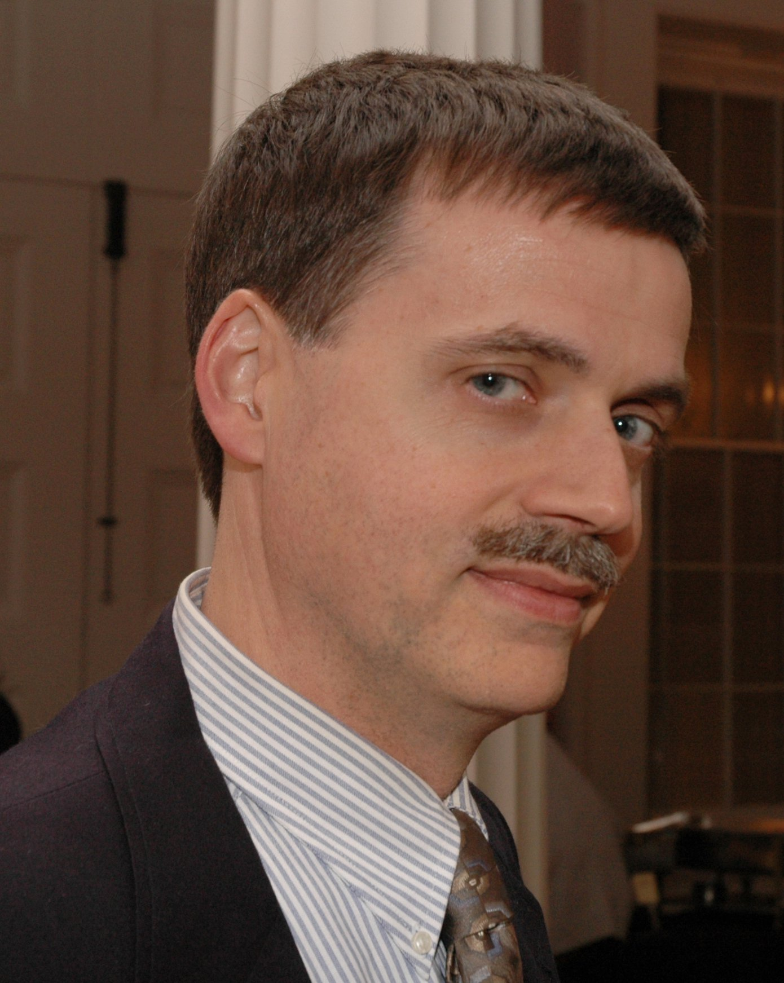
Kirk Corey is a
composer,
backpacker,
performer,
cook,
activist,
amateur beer critic,
self-appointed class clown emeritus,
recently re-awakened from a long nap with Mr. Van Winkle, during which time neither composed any music, ready to release his only composition of this millenium to an exclusive audience (that’s you). Born in 1962, studied composition with Herbert Brün from 1980 to 1987, then left for Iowa where he studied with Kenneth Gaburo. His presentation will include examples of his work, memories of Herbert, and thoughts about creating the music he doesn’t like (yet).

Next Presenters:

Susan Parenti/Ya’aqov Ziso, Urbana, Illinois
composers, activists, protest organizers Dec. 4
Patrice Repar, UNM, Albuquerque, New Mexico
composer, healthcare activist Dec .11

Presentations will be on Thursdays, 7-9p, at the Herbert Brün House,
122 Franklin Street, Urbana

Interactively--live at the Herbert Brün House:
- attend a single presentation (suggested $12*)
Non-interactively, view only (Q&A at the end of the presentation):
- attend a single streaming online presentation (suggested $8*)

No one turned away for lack of funds: Pay What You Can
http://inthelightof.bpt.me

Revenues from these series will reimburse travelling expenses of our visiting presenters, and ongoing projects at the Herbert Brün Society

