My Work in the Light of Herbert and Marianne Brün
Fall 2014 Series by Local & Visiting Artists/ Activists

The Herbert Brün Society & the School for Designing a Society are excited to offer their new joint venture this Fall 2014. National, international and local artists/activists -- former students of Herbert or Marianne Brün -- will be offering interactive presentations to talk about their work & the influence of Herbert or Manni on it.

Susan Parenti, composition, language, teaching and performance as means towards social change, SDaS
Ya’aqov Ziso, composer, anarchivist, agitating organizer in projects towards social change,
122 Franklin St., Urbana, Thursday, Dec. 4, 7-9p

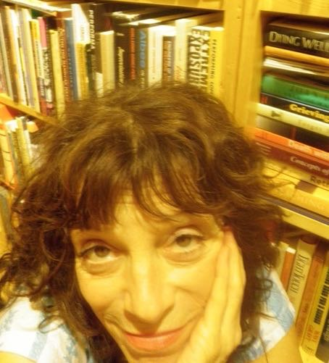
Susan Parenti,

teacher / organizer at the School for Designing a Society in Urbana Illinois; composer of experimental theater, music and situations.

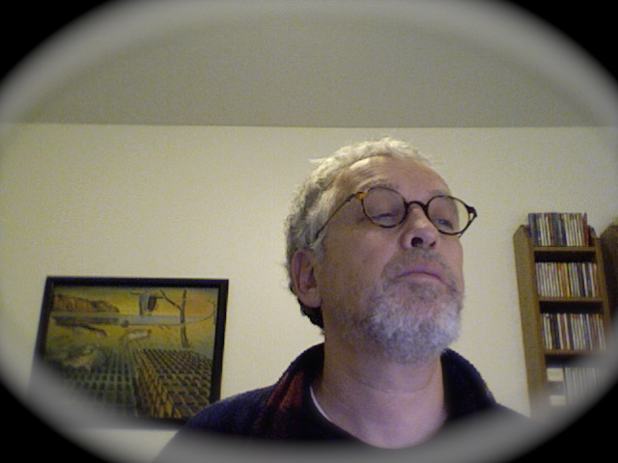
Ya’aqov Ziso,

collaborated with Herbert & Marianne Brün, the Performers Workshop Ensemble.
IT librarian for improving colleagues’ work conditions; back to composing music and social interactions.

Next Presenter:

Patrice Repar, UNM, Albuquerque, New Mexico
composer, healthcare activist Dec .11

Presentations will be on Thursdays, 7-9p, at the Herbert Brün House,
122 Franklin Street, Urbana

Interactively--live at the Herbert Brün House:
- attend a single presentation (suggested $12*)
Non-interactively, view only (Q&A at the end of the presentation):
- attend a single streaming online presentation (suggested $8*)

No one turned away for lack of funds: Pay What You Can
http://inthelightof.bpt.me

Revenues from these series will reimburse travelling expenses of our visiting presenters, and ongoing projects at the Herbert Brün Society

