My Work in the Light of Herbert and Marianne Brün
Fall 2014 Series by Local & Visiting Artists/ Activists

The Herbert Brün Society & the School for Designing a Society are excited to offer their new joint venture this Fall 2014. National, international and local artists/activists -- former students of Herbert or Marianne Brün -- will be offering interactive presentations to talk about their work & the influence of Herbert or Manni on their work.

Patrice Repar, composer, healthcare activist , music and integrative medicine, University of New Mexico

composer/activist Patrice Repar, chamber music, intermedia works, and electronic soundscapes; short films; design of original instruments and installations in medical environments; exploration of health and healing through the arts ….. across the US, Canada, United Kingdom, South America, Eastern Europe, Africa, and Australia …. Educator of music composition and arts-in-medicine … founder of Arts-in-Medicine: Healing and the Humanities, a program designed to enhance healing and health care through arts-based clinical service, education, research, community outreach, and international collaboration, where musicians, dancers, writers, visual artists and body workers engage patients, their families, and healthcare workers in creative encounters of a rejuvenating, transformative, and educational nature.

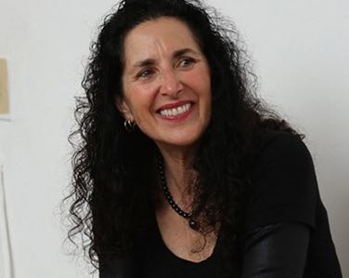

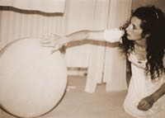

Presentation will be on Thursday, 11 Dec., 7-9p,
at the Herbert Brün House, 122 Franklin Street, Urbana

Attend:
Interactively--live at the Herbert Brün House:
- single presentation (suggested $12*)
Non-interactively, view only (Q&A at the end of the presentation):
- single streaming online presentation (suggested $8*)

No one turned away for lack of funds: Pay What You Can
http://inthelightof.bpt.me

Revenues from these series will reimburse travelling expenses of our visiting presenters, and ongoing projects at the Herbert Brün Society

