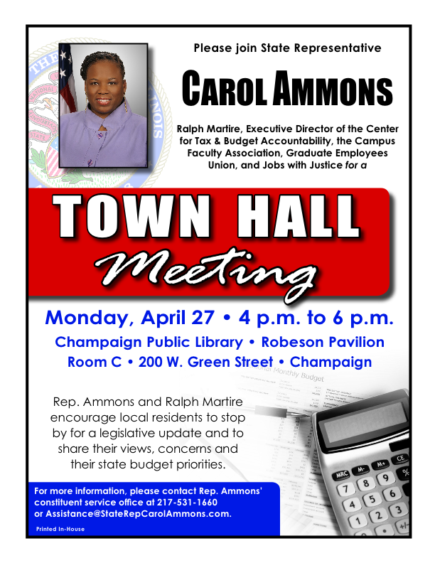

****************************************************************************************
State Representative Carol Ammons along with Campus Faculty Association (CFA), and the Graduate Employees Union (GEO) are hosting Ralph Martire from the Center for Tax & Budget Accountability on Monday, April 27th from 4-6PM at the Champaign Public Library. Mr. Martire's presentation, Reaction to the Governor's Budget, will provide an analysis of Governor Rauner's proposed budget and discuss long-term solutions for Illinois' financial issues. This program is also supported by CFA Non-Tenure Track Local 6546, Champaign County NAACP, Champaign-Urbana Area Project, and Jobs With Justice.

Bio of Ralph Martire

Ralph Martire is Executive Director of the Center for Tax and Budget Accountability. In February 2011, he was appointed to serve on the U.S. Department of Education Equity and Excellence Commission. Mr. Martire teaches a Master's class on Education Finance and Fiscal Policy for the University of Illinois and Roosevelt University where he is also a distinguished lecturer on public policy. Additionally, he has taught fiscal policy seminars for various universities and the International Fulbright Scholar Program. Mr. Martire has received numerous awards for his work on education policy reform, including the 2007 Champion of Freedom Award, presented by the Rainbow PUSH Coalition to individuals whose professional work embodies Dr. Martin Luther King, Jr.’s, commitment to equal educational opportunities, and the Ben C. Hubbard Leadership Award given by Illinois State University to individuals who have greatly benefited education in Illinois. He was elected to serve on the School Board of River Forest District 90, where he still serves. Ralph is also a regular columnist on education, fiscal and economic policy for the State Journal Register and Daily Herald.

Mr. Martire graduated from Indiana University Phi Beta Kappa, with a B.A. in History and received his J.D. from the University of Michigan.

He is married to Mary Kay Martire and they have two children, a son Nicholas, and a daughter Valerie. He coaches Little League baseball, boys basketball, and girls soccer.

The Center for Tax and Budget Accountability

WHO WE ARE
The Center for Tax and Budget Accountability was formed in 2000 to be a bipartisan, nonprofit research, and advocacy think tank that works across ideological lines to promote social and economic justice for everyone, from traditionally disadvantaged populations to the middle-class. Given how rancorous the current political environment is in our nation, the charge to design policy reform initiatives that were not only rigorous and evidence-based but would also bridge rather than reinforce ideological divides was both prescient—and crucial.

CTBA is dedicated to taking on large, systemic challenges by taking a data-driven, evidence-based, and best practice approach to:

- Promoting sustainable, long-term policy reforms in the core areas of education, social services, healthcare, and workforce/economic development;
- Tying the fiscal side of the ledger to service delivery—after all, to have quality services that meet demographically driven needs and generate desired outcomes, sufficient capacity on the front end is essential; and
- Framing all reforms in ways that bridge rather than reinforce ideological divides.
- CTBA believes it essential to have the commitment and ability to stay focused on resolving major inequities for the long term, and to work collaboratively with other experts, organizations, and opinion leaders to move the agenda forward. It is critical that work on structural issues be sustained over the long haul by a broad network of collaborating organizations and individuals, otherwise major policy changes will not occur.

