The Crisis in Burundi
And the Quaker Response

Tuesday, April 19, 2016 at Urbana-Champaign Friends Meeting
1904 E. Main, Urbana, IL
Public Presentation: 7 PM
Refreshments

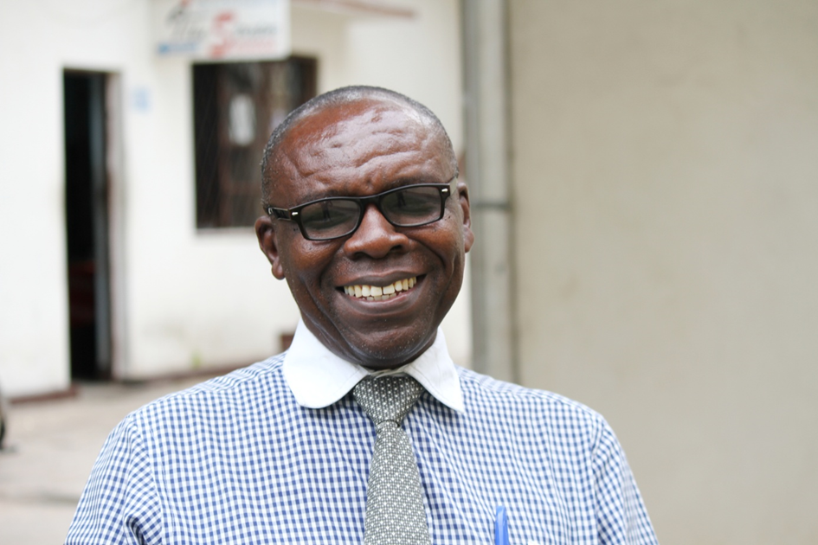

Join us to hear Pastor Elie Nahimana’s story: How Quakers in Burundi responded to the devastation of a civil war by developing a program - Healing and Rebuilding Our Communities (HROC).

HROC brings together Hutus, Tutsis, and Twa in the community for workshops, dialogue, and trauma healing. Pastor Nahimana’s talk will provide an opportunity to learn about a critically important international conflict as well as measures to prevent violence and promote healing.
Another opportunity to meet Pastor Nahimana: Center for African Studies’ Brown Bag Series. Wednesday, April 20, noon to 1 PM, International Studies Building, Room 101, 910 S. Fifth St., Champaign. Metered parking on the street.
For more information contact Charlotte Green, charlotteg588@gmail.com.

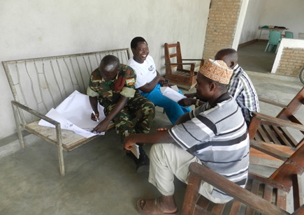

Photo taken during Peace Dialogue sessions in Buterere. Notice the
uniformed soldier – all factions are included in the dialogues.

