This is What Happens When Journalism Dies: Trump, Fake News, and Neofascism: A Discussion with Robert McChesney

Bio: Robert McChesney - Gutgsell Endowed Professor, Department of Communication, UIUC; co-founder Free Press, a national media reform organization; host “Media Matters”, weekly radio program, WILL-AM radio, 2002-2012; author of numerous books and articles, including Digital Disconnect: How Capitalism is Turning the Internet Against Democracy (2013) and The Political Economy of Media: Enduring Issues, Emerging Dilemmas (2008). Robert will be speaking to us through live streaming.

Date: Apr. 27, 2017
Time: 7 pm to 9 pm
Place: Channing Murray Foundation;
1209 E. Oregon St., Urbana

Parking: Free parking in the back of the building.

More info: www.channingmurray,org

Phone: 217-684-9920
What are the implications of Donald Trump’s attack
on the media for American democracy?

Can an already heavily monopolized and corporate-controlled media withstand Trump’s assault?
How are Trump’s attacks of a piece with neofascist policies of the past and present?
These are some of the issues Robert McChesney will address on Apr. 27th
at the Channing Murray Foundation.

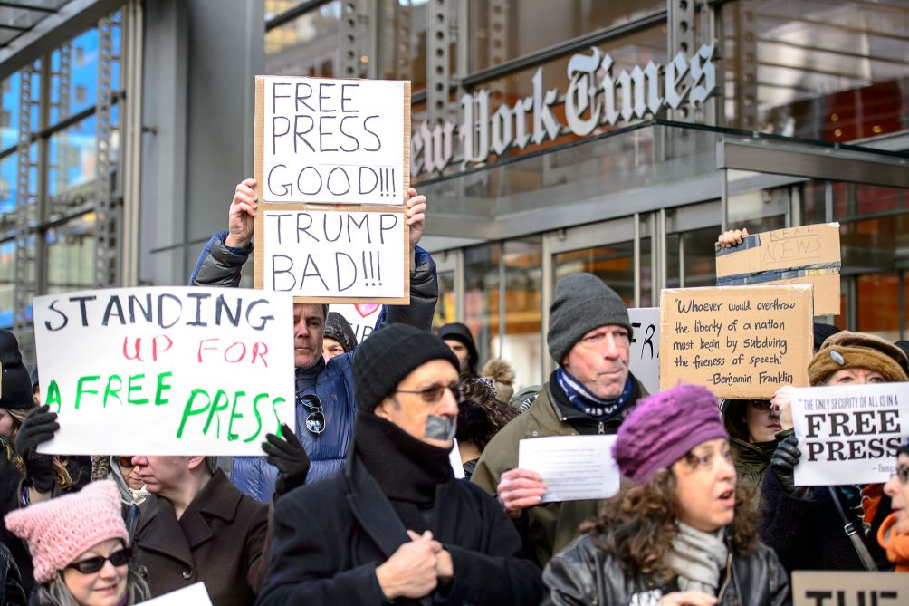
Sponsored by: Channing Murray Foundation
Co-sponsors: Central Illinois Jobs with Justice; Progressive Democrats of America; Social Action Committee, UUCUC;

